CSE ASSIGNMENT-2

-V.PHALGUN

AP21110010223

CSE-D

1.Inline Functions Code:

#include <iostream>

using namespace std;

inline int product(int x,int y)

{

    return x\*y;

}

int main()

{

    int a,b,res;

    cout<<"Enter the two values"<<endl;

    cin>>a>>b;

    res=product(a,b);

    cout<<"The Product is "<<res<<endl;

    return 0;

}

Output:

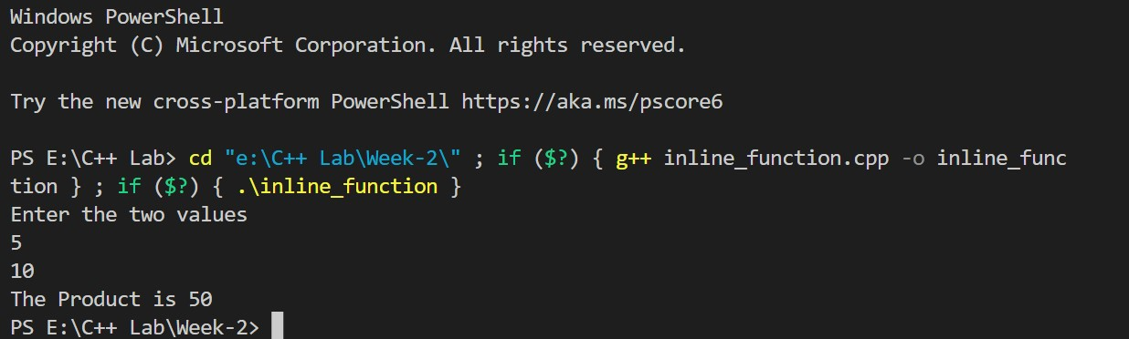

2(a) Call By Reference Code:

#include<iostream>

using namespace std;

void swap(int &x, int &y)

{

    int t;

    t=x;

    x=y;

    y=t;

}

int main()

{

    int a,b;

    cout<<"Enter Two Values"<<endl;

    cin>>a>>b;

    cout<<"Before Swapping"<<endl;

    cout<<"a="<<a<<" b="<<b<<endl;

    swap(a,b);

    cout<<"After Swapping"<<endl;

    cout<<"a="<<a<<" b="<<b<<endl;

    return 1;

}

Output:

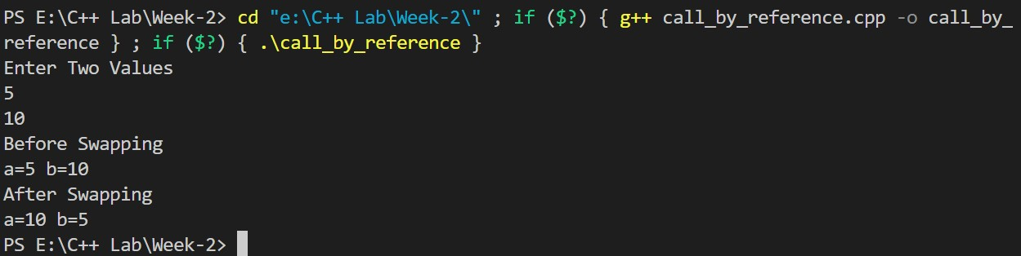

2(b)Call by Value:

#include <iostream>

using namespace std;

void swap (int a, int b)

{

  int t;

  t=a;

  a=b;

  b=t;

  cout<<"After swapping:"<<endl;

  cout<<"a="<<a<<" b="<<b<<endl;

}

int main()

{

  int x,y;

  cout<<"Enter two values: "<<endl;

  cin>>x>>y;

  swap(x,y);

  return 1;

}

Output:

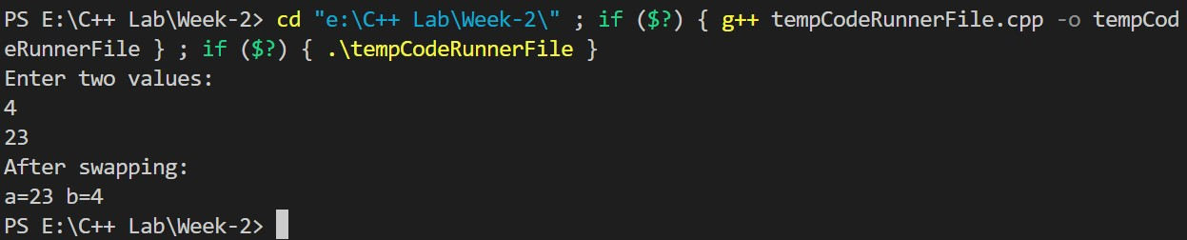

3.Storage Specifiers Codes:

a.Auto:

#include<iostream> using namespace std; void autoStorageClass()

{ cout<<"Demonstrating auto class\n"; auto a=32; auto b=3.2; auto c="Hello"; cout<<a<<"\n"; cout<<b<<endl;

cout<<c<<endl;

}

int main()

{

autoStorageClass();

return 0;

}

Output: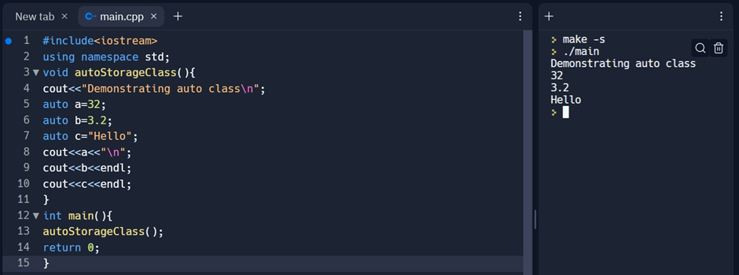

b.Extern:

#include<iostream>

using namespace std;

int x;

void externStorageClass(){ cout<<"Demonstrating extern class\n";

extern int x; auto b=3.2; auto c="Hello";

cout<<"value of variable 'x' "; cin>>x;

cout<<"Modified value of variable x"<<"declared as extern : \n"<<x;

}

int main(){ externStorageClass(); return 0;

}

Output:

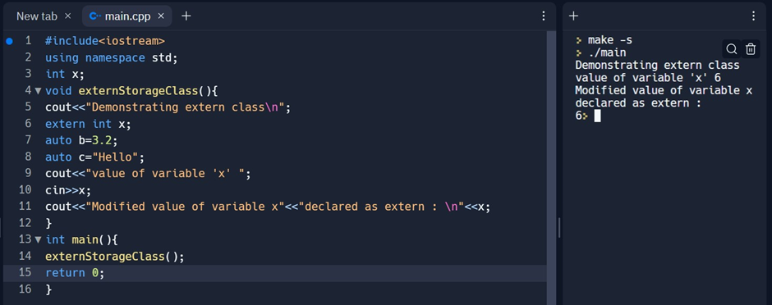

c.Register:

#include<iostream> #include<cstring> using namespace std;

int main()

{

char name[30];

register int i; cout<<"Enter a string : ";

cin>>name;

cout<<"The revers string is : "<<endl; for(i=strlen(name)-1;i>=0;i--)

{

cout<<name[i];

}

return 0;

}

Output:

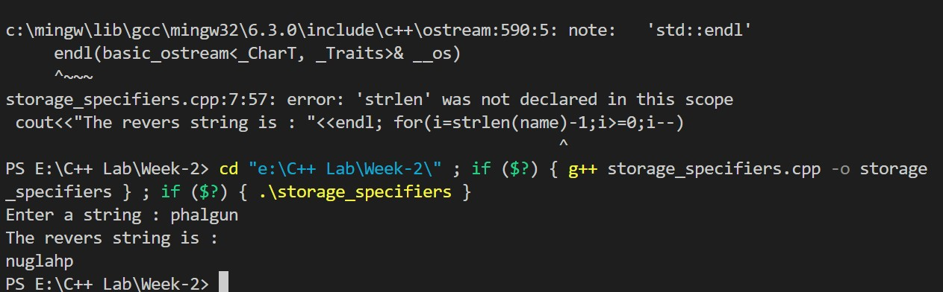

d.Static:

#include<iostream> #include<cstring> using namespace std; void printCount(void)

{ static int count=1; cout<<"count = "<<count<<endl; count=count+1;

}

int main(){ printCount(); printCount(); printCount(); printCount(); printCount();

return 0;

}

Output:

